CHAFFEY PARK RESERVE MASTER PLAN REVIEW

DRAFT REPORT
MARCH 2022

Table of Contents

- Introduction……………………………………………………………………………………..3

- Chaffey Park Reserve..………………………..………………………………………………4
  - Location…………………………………………………………………………………..4
  - The site……………………………………………………………………………………4
  - Site user groups and key stakeholders…………………………………….6

- Master Plan Review…………………………………………………………………………..7
  - Previous Master Plan objectives and directions……………………….7
  - 2009 Master Plan progress report……………………………………………8

- Future Directions………………………………………………………………………………9
  - Development opportunities…………………………………………………….9

- Master Plan Implementation…………………………………………………………….9
5.1 Action and implementation……………………………………………………..9
5.2 Priority Actions List………………………………………………………………….11

Appendix 1: Consultation and literature review……………………………………15
Appendix 2: Chaffey Park Map with action items………………………………….16

- Introduction
The current Master Plan for Chaffey Park Reserve was developed in 2009. The Master Plan’s intent was to guide the planning and development of the Reserve over the next 10 years.
In 2020, Mildura Rural City Council (MRCC) undertook a process to review the Master Plan for Chaffey Park Reserve. This review will be complete in 2022.
The aims and objectives for each of these Master Plan Reviews are to:
• Identify current and future facility needs in consultation with existing user groups and internal stakeholders.
• Ensure agreed developments align with recreation and asset management planning principles.
• Incorporate identified developments into an action plan with priority ratings, indicative costs and potential funding contributors so as to provide clear direction for Council and user groups for the next 5 years and beyond.
Projects identified in the 2009 – 2019 Master Plan that have recently been completed are;
- Management / restriction of traffic through the park through the installation of bollards and seating around the oval
- Additional tree and vegetation plantings through the park and along adjoining roadsides
- Installation of play areas, picnic and BBQ areas
The projects listed above generally align with the Master Plan’s action list, however through detailed design and further consultation with the community and user groups they have developed and varied over time. With this, it is important to undertake a review of the current Master Plan in order to accurately capture the work that has been completed in order to effectively determine the priorities for the reserve over the next 5 years.
A number of regular user groups have recently approached Council requesting support for further major facility developments. Some of these projects are not captured in the current Master Plan. This review will ensure that these proposed developments are considered in partnership with other key user groups and the broader community, are considered through an integrated approach and that the works are reflective of current and future needs. Due to the change in use and demand at the reserve it is important that the review is undertaken in order to ensure the Master Plan’s identified actions are relevant and prioritised in alignment with the community’s, internal stakeholders and current users expectations and desires.
The review has given consideration to the existing Master Plan (2009) as well as site conditions and future anticipated needs of the Reserve’s user groups.
The revised five year Master Plan will provide guidance for MRCC, in their aim to enhance the Reserve and ensure its facilities continue to benefit key user groups as well as the broader local community.
The following process was completed to ensure the revised Master Plan aligned with MRCC’s relevant strategies and policies, and was locally focussed.
All uncompleted actions from the 2009 Master Plan that still remain relevant have been incorporated into the 2022 revision and a range of plans, strategies and policies which reference or impact on the future direction of recreation provision in Irymple have also been considered as part of the process.
Numerous MRCC officers were engaged throughout the review process. A key role of these officers was to assess the technical feasibility of proposed user group actions and also identify any infrastructure upgrades deemed necessary for the future operation of the Reserve.
Development of the revised Master Plan has been largely driven by the Reserve’s regular user groups with support and assistance from Council’s Recreation Planning & Development (RP&D) Staff. Consideration has been given to the changing needs of these user groups as well as the capacity of all stakeholders to deliver the recommended actions.
A strong focus of the Master Plan review was to ensure that the future direction of the Reserve was based on key elements of sustainable decision making. That is, proposed actions need to be economically viable, technically feasible, environmentally compatible and publicly acceptable.
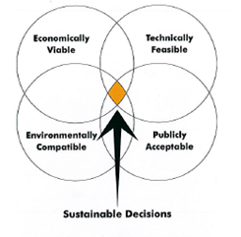
The development of a clear future direction for Chaffey Park Reserve along with a program of prioritised works, indicative associated costs and potential contributors is provided in section 5.2

- Chaffey Park Reserve

  - Location
Chaffey Park is located on the eastern fringe of the town of Merbein which is approximately 18 kilometres north-west of Mildura. Merbein is at the heart of the Sunraysia Irrigation District which means its primary citrus, grape and dried fruit industries are sustained by irrigation from the Murray River. At the last census (2006) the population of Merbein / Merbein South was 3127 having declined to 3,127, a decline of 250 people or 7.4% between the 2001 and the 2006 census.

  - The Site
Chaffey Park is approximately 4.8 hectares in size. Chaffey Park is crown land (Department of Sustainability and Environment) with council the designated committee of management. Tenant groups use the park under a lease agreement or service agreement with council.

Figure 1 – Aerial image of Chaffey Park

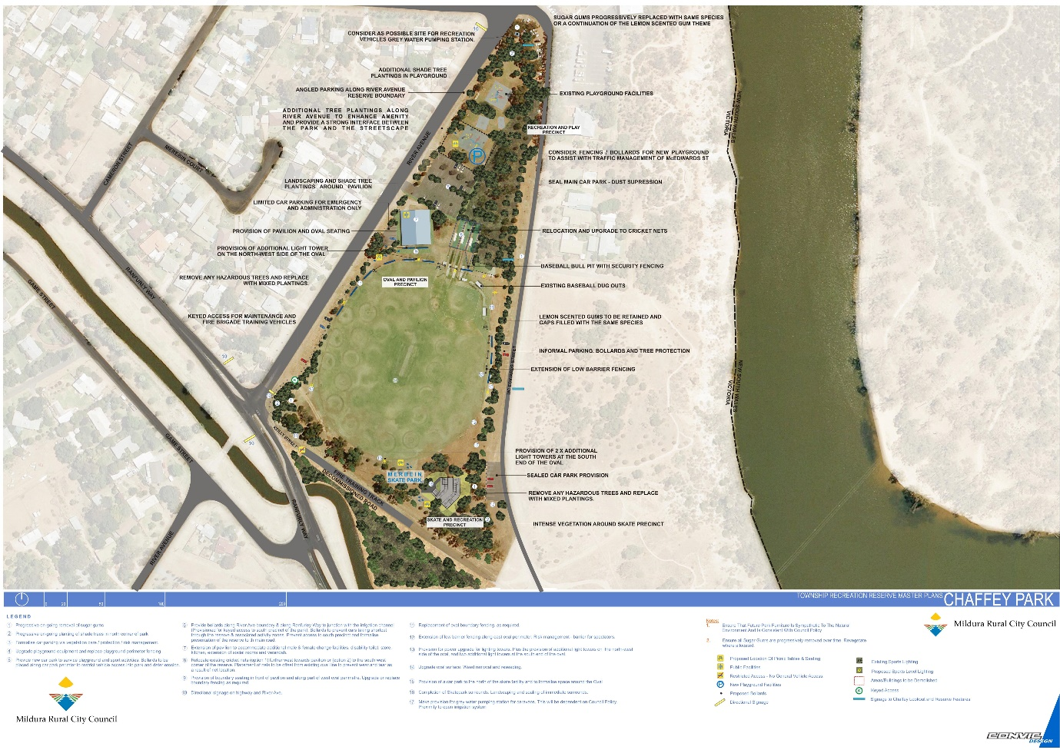

Facilities and Structures

Facilities and Structures on the site include:

- 1 Sports field that caters for cricket and baseball
- Cricket nets with 1 cricket/baseball batting cage
- Clubrooms
- Baseball back net (over Winter only)
- 1 playground
- Picnic and BBQ facilities
- A skate facility and a
- CFA training track
  - Site User groups and key stakeholders

There are currently 4 regular user groups based at Chaffey Park. These include:

- Merbein South Cricket Club
- Saints Baseball Club
- Merbein CFA
- Sunraysia Cricket Association (Women’s Competition)

The number of user groups has declined since the 2009 Master Plan was developed with the Meringur Football Club moving to Kenny Park for its training facility to provide netball courts for their female members.

Each user group were provided with a template and support from RP&D staff to develop individual organisation facility plans (refer to Appendix 1 for a list of representatives). This part of the planning was undertaken during Covid-19 restrictions when face to face meetings were not possible and worked well. It allowed the process to continue and also provided each club with their own facility plan. It is recommended that this process continue post Covid.

MRCC is responsible for the majority of maintenance tasks at the Reserve with Building Maintenance, Parks Services and Asset Services all playing significant roles in ensuring the Reserve’s ongoing operation. Minor maintenance such as cricket wicket preparation is carried out by the cricket club.

- Master Plan

  - Previous Master Plan objectives and directions
In 2009, MRCC commissioned the development of a Master Plan for Chaffey Park. The following section provides a summary of the key issues and needs identified in the 2009 Chaffey Park Master Plan.
- Upgraded / expanded pavilion to cater for both cricket and baseball
- Completion of skate facilities and landscaping of the area
- Upgrading of playing surface and irrigation system
- Management / restriction of traffic through the park
- Greening of the park with additional tree and vegetation plantings through the park and along adjoining roadsides, and removal of hazardous trees
- Upgrading of ‘family friendly’ features including play areas, picnic / BBQ areas and shade

  - 2009 Master Plan progress report
The following list provides a summary of key developments that have been completed at Chaffey Park since the development of the 2009 Master Plan:
- Management / restriction of traffic through the park through the installation of bollards and seating around the oval
- Additional tree and vegetation plantings through the park and along adjoining roadsides
- Installation of play areas, picnic and BBQ areas

A review of the status of actions from the 2009 Chaffey Park Master Plan highlighted that a large number of actions remain incomplete. However, it should be noted that recent changes in usage and subsequent user group development priorities has meant that these may no longer be applicable.

- Future Directions

  - Development opportunities

A number of site development opportunities were identified throughout the consultation process with user groups and Council officers. The following opportunities received strong support and therefore have been identified as high priority.

- Modification of existing clubrooms to include change facilities that support intended usage.
- Upgrades to the Merbein Fire Brigade running track
- Planning and construction of a linear skate/bike track to complement the existing skate bowl

- Master Plan Implementation

  - Action and implementation
The revised Master Plan for Chaffey Park has been developed to provide actions that are practical and realistic. Many actions will require further stakeholder consultation through their detailed design and implementation phases.

The priority actions of the Master Plan have been established based on the following criteria:

Priority 1 - High level demand by clubs, safety and regulatory compliance
Priority 2 - Medium level demand by clubs, necessary repairs to maintain operations
Priority 3 - Upgrades / refurbishments / exclusive requests

The implementation of the Master plan is reliant upon the capacity of a range of stakeholders to actively attract and negotiate funding. To this end, it is important to appreciate that implementation of the Master Plan is not the sole responsibility of one stakeholder. Rather, its success is dependent upon a range of partners to come together and work towards mutual goals.

The action list in Section 5.2 identifies the range of partners that are involved throughout the implementation of the works program. Funding contribution recommendations have been made on the basis of:

• Which partner/s will receive direct benefit from the works;
• The assumed capacity of partners to contribute to works;
• The understanding that Council, together with the user groups, has a responsibility to preserve asset integrity, and respond to works that would otherwise contribute to asset deterioration and compromise the functionality of the asset.

Finally, recommended contributions have not taken into account the expected in kind contributions. It is anticipated that in kind contribution which directly reduces the capital cost of work is a fair and legitimate avenue for all Clubs to contribute to works. However, it should be noted that Council discretion will be used in assessing and/or approving any proposed in kind.

In some cases, identified projects may also be eligible for funding from Council’s grants or State and Commonwealth Government programs and will rely on a successful funding application to deliver the project.

  - Priority Actions List
 | Task | Priority | Indicative Cost |  |  | Potential Funding Partners | Comments
# | Oval Precinct
1 | Modification of existing clubrooms to include change facilities that support intended usage. | Priority 3 | $25,000 | Council | Potential Recreation Facilities Upgrade grant
2 | Increase the width of the Merbein Fire Brigade running track | Priority 1 | $5,000 | Council | Potential Community Grant
3 | Install a light facing the Merbein Fire Brigade track to improve safety | Priority 1 | $11,000 | Council | Potential Community Grant
4 | Construction plans developed for a formalised car park between the pavilion and playground. | Priority 2 | $50,000 | Council | Capital Works Bid
5 | Construction of a formalised car park between the pavilion and playground. | Priority 3 | $135,000 | Council | Capital Works Bid
6 | Plans developed for a linear skate track to link up with the existing skate bowl. | Priority 2 | $6,000 | Merbein Development Group | Concept Plans Complete by Convic for Merbein Dev Assoc Inc
7 | Construction of a linear skate track to link up with the existing skate bowl. | Priority 3 | $350,000 | Merbein Dev Group, Council, State Gov’t | Design allows for delivery in two stages.
8 | Develop outdoor historical interpretive area at the south eastern end of Chaffey Park in line with existing concept plan. | Priority 2 | $20,000 | Community Futures | Community Futures are supporting Merbein District Historical Society to implement their concept plan for the south eastern end of Chaffey Park. To ensure this area is not encroached on it is necessary that both plans are recognised in this Master Plan.
 | Total |  | $552,000

Note: Indicative costs for identified works are based on 2021 prices and may be subject to increase at time of project commencement.
Indicative costs listed as TBC are due to the exact scope of those action items being unknown at this stage.

Priority 1 - High level demand by clubs, safety and regulatory compliance
Priority 2 - Medium level demand by clubs, necessary repairs to maintain operations
Priority 3 - Upgrades / refurbishments / exclusive requests

- Appendices
Appendix 1 - Consultation and literature review
A – 1.1 Stakeholder consultation list
A list of stakeholders consulted in the development of the Revised Mildura Recreation Reserve Master Plan is provided below:

- Aaron Walder – Merbein South Cricket Club
- Steve Russell - Merbein Fire Brigade
- Rebecca Willcock - Merbein Fire Brigade
- Sheree Curtis - Merbein Fire Brigade
- Steve Walker - Saints Baseball Club
- Gloria Wall - Merbein Development Ass. Inc.
- Bernadette Wells - Merbein Historical Society
- Andrew Lucchesi – Recreation Officer
- Sharyn Arnold – Facility Projects Team Leader
- Thomas Stevenson - Recreation Development Coordinator
- Dean Umback – Parks & Gardens Coordinator
- Geoff Burr – Community Development Officer

A – 1.2 Literature review
- Chaffey Park Master Plan 2009-2019
- Recreation Strategy
- Merbein Community Plan
- Public Open Space Strategy

