Red Cliffs & Carwarp

Community Plan Draft

2023 – 2028

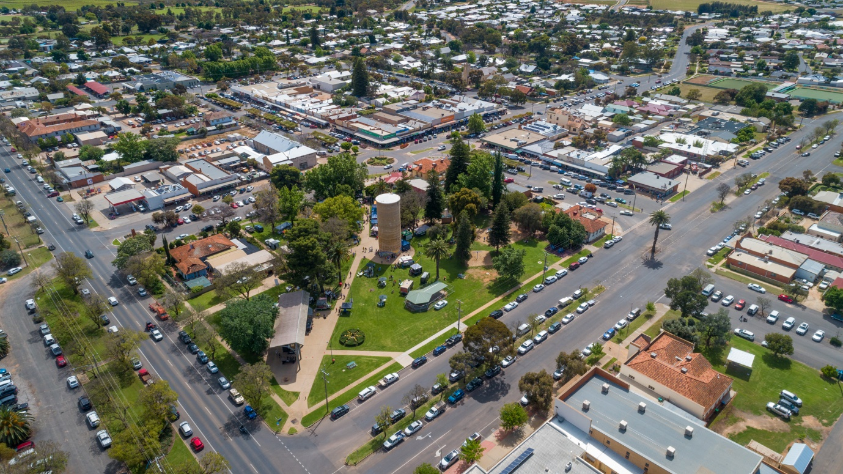

This community plan includes the areas known as Westcliffs, Nursery Ridge, Cliffside, Stewart, Karadoc, Sunnycliffs, Yatpool and Carwarp.

Red Cliffs Our Story

Location

Red Cliffs is the southern gateway to Sunraysia on the Calder Highway, 544 kilometres north-west of Melbourne.
A thriving community, with a population of 6138 (2021) it borders the Murray River to the east, the vast Murray Sunset National Park to the west, the Hattah Kulkyne National Park to the south and Mildura lies 16 kilometres to its north.

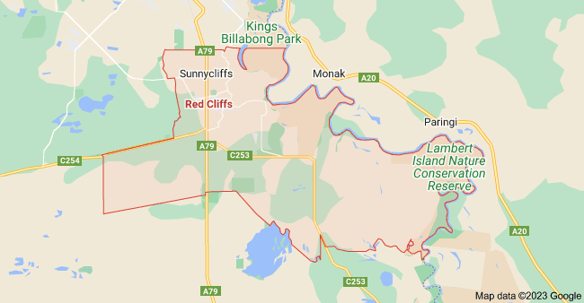

CENSUS DATE | POPULATION
2011 | 4625
2016 | 5060
2021 | 6138

Country of birth
2011 |  | 2016 |  | 2021
Australia | 4,006 | Australia | 4112 | Australia | 4284
England | 70 | England | 79 | England | 79
Italy | 69 | Italy | 52 | Malaysia | 76
New Zealand | 46 | New Zealand | 44 | Italy | 40
Turkey | 24 | South Africa | 19 | India | 37
Germany | 14 | Turkey | 17 | New Zealand | 30

AGE
Years | 2011 | 2016 | 2021
0-9 years | 534 | 635 | 607
10-19 years | 747 | 648 | 670
20-29 years | 464 | 542 | 618
30-39 years | 459 | 543 | 648
40-49 years | 663 | 620 | 593
50-59 years | 690 | 769 | 727
60-69 years | 481 | 659 | 723
70-79 years | 336 | 361 | 432
80 years and over | 253 | 273 | 268

Red Cliffs Community over time
There has been community here for thousands of years. The extensive mussel middens at the cliffs are evidence that First Nations people met here in community to fish and feast. The river and associate waterways ensued plentiful bird and animal life. This place had abundant quandong trees, yam bulbs and other bush foods as well as the tough belar trees essential for strong tools. Red Gum along the river have scars to indicate river craft and utensils were manufactured for the community living of the local people.
In 1887 Mildura was planned as an irrigation settlement community. This included Red Cliffs but it was not cleared for settlement at this time. The railway came through from Melbourne to Mildura in 1903. Small communities like Yatpool and Carwarp established with dryland farms, centred around their railway siding, local hall and stores.
After World War One the Red Cliffs area was acquired for the settlement of returned soldiers. This began a new venture in community under the organisation of the State Rivers & Water Supply Commission. At first it was a largely male community, organised military style in work gangs, surveying and clearing the Mallee bush. The workers lived in temporary buildings and tents with a mess providing meals and a few amenities. Soon women and children were part of the community and returned servicemen came from around Australia and from many nations to work here and apply for their own block. It was a multinational community with some French, Italians, New Zealanders, Scandinavians and a large group from the British Isles: Scots, Welsh, Irish and English. The common link was their shared war experience and the hope for a future in a community created anew by themselves. The first town was set up on the west of the railway from May 1920. It had rough-built buildings for shops, a Post Office, boarding and dining rooms, banks, a doctor, a policeman, a picture theatre, a billiard room, a Druids Lodge and even a shooting gallery. The main recreation hall was used as a school and church. The Tent Town leases terminated on 30 June 1922.
The permanent town was planned with much thought with a grid plan as in Mildura and around a town square like many European villages. By 1921 the current town allotments were for sale and being built upon, beginning the community centre for Red Cliffs. But the building of community was already there. Rough living with communal eating, working in gangs and the women coping together with pioneer conditions was creating friendship bonds and lifetime relationships.
The first substantial public building was Diggerland a picture theatre and public hall. This was a cooperative venture with locals investing in shares in Diggerland Ltd. Soon the community were creating organisations to support the development of the district. This led to a meeting in Diggerland in February 1923 to discuss forming a representative organisation for the benefit of the whole community – town and district. This meeting formed the Red Cliffs Progress Association and also inspired a wish-list for our first community plan.
Over the next 100 years Red Cliffs retained that spirit of community, camaraderie, self-help, support and care. Most of our public amenities were collectively lobbied for and built by working bees and donation. We established churches, lodges, sporting clubs, musical and dramatic groups, an RSL Branch, women’s groups, schools, kindergarten, a child health centre, a library, doctor and dental facilities, a hospital, a nature study society and a first rate swimming baths. Our agricultural beginnings in dried fruit carried through more than 75 years as the centre of our economy. These relied on cooperative processing and sharing of knowledge and ideas for the good of all. Our community came up with ideas to combat frost damage, rallied in times of flood, and on numerous occasions after severe storms. We showed compassion in times of tragedy and loss, fed those in hardship, cared to advocate for change of regulations when necessary or to protect our environment.
The district has changed and Red Cliffs is served by a wider community for most facilities and services. Many dried fruit blocks have diversified to other industries. Channelled irrigation supply ceased in 2016. Land near to the town has been subdivided for housing. The local shopping and commercial options have greatly changed. Red Cliffs is a breakfast stop for the many workers commuting each morning and a temporary home for the seasonal workers from overseas. These changes create challenges as reflected in our community survey responses.
Our previous community plan had the centenary as its central motivation. COVID-19 threatened the celebration plans but the organisers creatively made changes and the four-day celebration in April 2022 saw many return. We all participated, enjoyed and shared memories together with others who call Red Cliffs home. The spirit of community was very evident in all aspects of the centenary events. Our centenary book won the 2022 Victorian Community History Project Award and the centenary event received local Australia Day community awards. Now we step into the future Red Cliffs together with new aspirations and plans for our community. This is our Community Plan for 2023-2028.
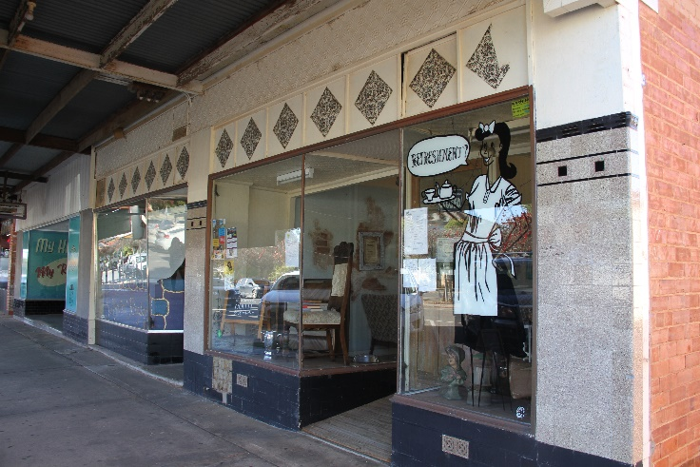

Purpose of the Red Cliffs Community Plan

Community planning is about Red Cliffs community members coming together to shape the

future, thus creating a greater ownership of the plan that affect the area and empowers local people to play an active role in what happens in the town in which they live. The success of the community plan relies on the commitment and participation of the community.

Building on the Red Cliffs Community Plan 2016-2021, in 2022 we started the process of renewing the plan to reflect our community’s values, aspirations and priorities for the next five years. The process involved residents identifying assets of their community and what they appreciated about living in the region. The Red Cliffs & Carwarp Community Plan 2023-2028 sets out the five-year vision for Red Cliffs and Carwarp based on the aspirations of our community and the priorities they told us were important.

The Red Cliffs Community Plan Advisory Committee has taken the lead in reviewing and renewing the plan after community consultation through a community survey and picture boards assisted by Mildura Rural City Council. At these consultations the planning process was explained, during which the key areas from the previous plan were shared and discussed. This included ideas, priorities, and projects.

How we engaged

Community and stakeholder engagement was central to everything we did in developing this plan. It not only informed our priorities, but it kept us on track throughout the whole process. Below is a summary of the engagement schedule we used to develop the plan.

19 May 2022 – The Red Cliffs Focus Group held a public meeting to discuss the development of a new community plan. Attracting around 30 community members, the Red Cliffs Community Plan Advisory Committee was formed from this meeting.

August 2022 - The Red Cliffs Community Plan Advisory Committee first met with Mildura Rural City Council to discuss the Community Plan review and to action the processes to commence.

25 November 2022 – Media Release regarding Community Plan and the first consultation sessions

4 December 2022 - The Red Cliffs Community Planning Advisory Committee and Mildura Rural City Council facilitated a community session, seeking input from residents on the review of the new Red Cliffs Community Plan.

Surveys are made available online and physically at:
- A S Kenyon Library Red Cliffs
- Coffee on Indi
- Red Cliffs Community Resource Centre
- Red Cliffs Club

4 December 2022 – Carols by Candlelight pop-up engagement table in Barclay Square before the event started.

17 December 2022 – Lions Club official BBQ opening at Barclay Square pop-up engagement table.

20 January 2023 – Summer Sounds Pool Party - working in partnership with Hands up Mallee to engage young people in the consultation process of the review in the new Red Cliffs Community Plan with picture boards. Event included a live DJ, free sausage sizzle & zooper doopers and prizes.

26 January 2023 - Red Cliffs Community Plan was the theme addressed at the Australia Day Service Club’s Breakfast in Barclay Square, with a table for any follow-up discussion or comments and to distribute surveys.

15 February 2023 – Red Cliffs Scouts consultation process of the review with picture boards

16 February 2023 – Survey postcards sent to Sunny Cliffs residents.

20 February 2023 – Survey postcards sent to Carwarp residents.

21 February 2023 – Lions and Rotary Clubs combined meeting face-to-face community session.

22 February 2023 – Red Cliffs Girl Guides consultation process of the review with picture boards

23 February 2023 – Red Cliffs Foodworks Supermarket face-to-face community session

24 February 2023 – Red Cliffs Club face-to-face community session

27 February 2023 – Red Cliffs Primary School consultation process of the review with picture boards

28 February 2023 – St Joseph’s Primary School & Red Cliffs East Primary School consultation process of the review with picture boards & survey questions

1 March 2023 – Red Cliffs Community Consultation - Councillors discussed local issues together with community.

2 March 2023 – Red Cliffs Post Office face-to-face community session

5 March 2023 – Red Cliffs Market face-to-face community session

10 March 2023 – Red Cliffs IGA face-to-face community session

The consultation period with surveys and visual boards resulted:
- 187 hardcopy and online completed surveys
- 145 visual board participants

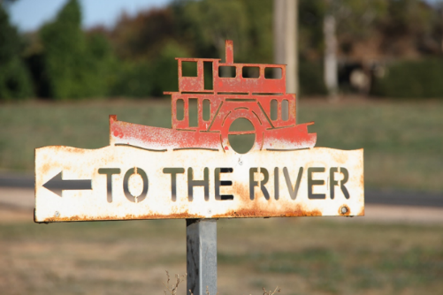
Our Vision: To create a vibrant, sustainable, and inclusive community where all residents can thrive.
Mission/Purpose Statement: The purpose of our community plan is to identify the needs and priorities of our community, and to develop a shared vision for the future. Through collaboration and engagement, we will work together to create a plan of action that addresses local problems and opportunities, and guides planning and land use management.
Values: We believe that by working together, we can create a better future for all residents.

Major achievements from the Red Cliffs Community Plan 2016 – 2021

- Replacing the iconic Red Cliffs Boardwalk on the Murray River
This structure is a much loved and well used facility by locals and tourists. It became a focus and passion of the community to ensure its replacement and to reinstate the significance and utilisation of the facility and the surroundings.

- Red Cliffs Barclay Square upgrade
The Lions and Rotary Clubs of Red Cliffs provided the community the projects they had proposed for Barclay Square. The Lions Club project included the extension of the existing rotunda shelter roof line and the addition of a BBQ, tables and chairs. The Rotary Club’s project was installing adult exercise equipment.

- Red Cliffs Centenary Celebrations
The Red Cliffs irrigation district (including Cardross) was officially opened in November 1921. The centenary of this event was celebrated with a back-to long weekend of fun and catching up for everyone who has ever felt a connection to the place. The Centenary publication ‘Red Cliffs Recollections’ won the 2022 Victorian Community History Award.

- Establishing the Red Cliffs Men’s Shed
Providing a welcoming environment for men from Red Cliffs and surrounds who are from all walks of life where they can socialise and enjoy a wide range of activities.

- Red Cliffs beautification

Red Cliffs town centre represents more than just a geographical point, it is also the heart and soul of the community. With the establishment of the Peacewalk, mosaics, story posts, town gardens, artificial grass and planter boxes, street benches and bin covers there has been a transformation into a vibrant space, generating a deep sense of community pride.

- Promoting our Community

The Lion’s Club updated the signage in the tourist park entry ‘Welcome to Red Cliffs’ and provided covered picnic facilities beside it.
A screen showing a weekly news segment of Red Cliffs events was installed in the newsagent’s window, this was supported and managed by the Rotary Club.

Safety
Objective: A safe community that fosters a sense of belonging and community pride.
Actions | Next steps | Partners | Links
- Advocate to reduce the incidence and impact of crime, and keep the community safe through initiatives, programs and partnerships.  - Address the traffic concerns of the community while maintaining good levels of accessibility for local residents, local businesses and emergency services e.g., Traffic lights, roundabouts installation and pedestrian crossings. | Work with Mildura police on Community Based Policing projects. Red Cliffs community to look at opportunities to work in collaboration on projects. E.g. Establish Neighborhood Watch & Safety Houses programs.  Work with Council Road Safety Officer and Regional Roads Victoria. | Mildura & Red Cliffs Police, Council, Community Futures unit, Neighborhood Watch, Red Cliffs Focus group, Red Cliffs School, Red Cliffs Community resource centre.  MRCC Road Safety Officer, Regional Roads Victoria Red Cliffs Schools, Mildura & Red Cliffs Police, Red Cliffs Focus group. | - MRCC Community Health & Wellbeing Plan 2021-2025  - Council Plan 2021-2025 – Advocacy Plan  - MRCC CCTV Program  - Municipality Council Neighborhood safer place plan.  - MRCC Road Safety Strategy  - Community Safety plan 2015-2020  - Council Plan 2021-2025
Township Improvements
Objective: Creating a clean accessible town, encouraging development of small businesses.
Actions | Next steps | Partners | Links
- Adopting universal design principles throughout the community e.g. upgrade, or new footpath, ramp installation.  - Investigate and assess the upgrading, replacement and/or new installation of public toilets.  - Examine a viable business model to encourage commercial business diversity e.g. restaurants, take away.  - Inspire an act of civic pride working together as a community to clean up, fix up and conserve the environment. | Work with MRCC Works & Infrastructure Department and DAAC  Work with MRCC Facility Services Team, Red Cliffs Focus Group, Community Consultation  Investigate opportunity for creating a Business Plan for Red Cliffs CBD  Establish a community working group to develop ideas, methods and public community grants available in attracting and retaining new business opportunities.  Identify areas and groups to create a program for regular clean up days.  Investigate programs for roadside and public space clean ups.  Support MRCC to implement ongoing green waste collection.  Provide community education on how to use Snap, Send and Solve regarding illegal dumping of rubbish, overgrown trees, etc. | Mildura Council Engineering, DAAC, Red Cliff Focus group, Red Cliffs Community, Council Community Development department.  MRCC Facility Services Team, Red Cliffs Focus Group, Red Cliffs Community, Parks Victoria.  Community Development Team, Red Cliffs Focus Group, Community groups, residents, internal and external stakeholders, market committee, Mildura Development Corporation.  Red Cliffs Focus Group and Community, MRCC Environmental Sustainability Unit, MRCC Parks & Gardens, MRCC Waste Services, Landcare | - Council Community Access and Inclusion Plan 2014 -2018  - Council Plan 2021-2025  - Changing Places  - Council Plan 2021-2025  - Mildura Public-Toilet Strategy  - Mildura Public Toilet Toolkit  - Quandong Park Masterplan 2020  - Changing Places  - Council Plan 2021-2025  - MRCC Community Vision 2021-2040  - MRCC Visitor Servicing Strategy 2021-2025  - MRCC Environmental Education Plan 2020-24  - MRCC Environmental Sustainability Report 2020-21  - MRCC Litter and Illegal Dumping Strategy 2020-25  - MRCC Waste and Resource Recovery Strategy 2022-26  - MRCC Invasive Plants and Animals Plan 2020-24  - MRCC Vegetation Management Plan 2020-24  - MRCC Parks and Waste Services  - Environmental Education Plan 2020-2024
Advocacy
Objective: Using the Red Cliffs ‘Community Spirit’ to be resilient and diverse.
Actions | Next steps | Partners | Links
- Advocate in recruiting and retaining health practitioners.  - Campaign for implementing integrated health and aged care services.  - Investigate alternatives to bank branch models that would maintain or improve banking services and accessibility in areas where branches have been closed.  - Support the establishment of a childcare centre.  - Creating a Family/Child Hub incorporating an extension/upgrade to the current Kindergarten and Maternal Child Health Centre  - Investigate and improve public transport options. | Work with Sunraysia Community Health Services and Mildura Base Public Hospital and Jacaranda Village on ideas and possibilities.  Work with Sunraysia Community Health Services and Mildura Base Public Hospital, Jacaranda Village  Establish a community working group to investigate the different banking opportunities available to small towns e.g. Customer Owned Bank  Work with Red Cliffs Kindergarten, Red Cliffs Primary School, Red Cliffs East Primary School, St Joseph’s Primary School, MRCC Maternal and Child Health, MRCC Community Futures Department to investigate funding available.  Work with MRCC Early Years Services & Community Development to obtain building funding.  Consult with Public Transport Victoria on bus routes during their next review.  Consult with Mildura Taxi companies regarding providing regular service to area.  Rail integrated transport strategy | Mildura Base Public Hospital, Sunraysia Community Health Services, Mildura Rural City Council, Community Futures Department, Focus group, Loddon Mallee Health Unit, Mallee District Aboriginal Services,  Murray PHN, The Red Cliffs Community Resource Centre.  Mildura Base Public Hospital, Sunraysia Community Health Services, Mildura Rural City Council, Community Futures Department, Focus group, Jacaranda Village, Department of Health, Mallee District Aboriginal Services (MDAS), The Red Cliffs Community Resource Centre.  Red Cliffs Focus Group, MRCC Community Futures Department, Community Groups, residents, The Red Cliffs Community Resource Centre.  Red Cliffs Kindergarten, Red Cliffs Primary School, Red Cliffs East Primary School, St Joseph’s Primary School, MRCC Maternal and Child Health, MRCC Community Futures Department, Hands Up Mallee, Red Cliffs Church of Christ, Red Cliffs Community Playgroup.  Red Cliffs Kindergarten, YMCA, DET, MRCC Early Years Services & Community Development, MRCC Maternal Child Health Service, Toy Library, Red Cliffs Families Project Team, Hands Up Mallee, Red Cliffs Focus Group, Red Cliffs Resource Centre & local schools.  Public Transport Victoria,  Mildura Bus Lines,  Regional Roads Victoria, Red Cliffs Community, Red Cliffs Focus Group, Mildura Taxis, City Taxis Sunraysia, Urcab Mildura, V-Line | - MRCC Community Health & Wellbeing Plan 2021-2025  - Council Plan 2021-2025 – Advocacy Plan  - MRCC Community Health & Wellbeing Plan 2021-2025  - Council Plan 2021-2025 – Advocacy Plan  - Community-Vision-2021-2040  - Council Plan 2021-2025  - Community-Vision-2021-2040  - MRCC Community Health & Wellbeing Plan 2021-2025  - Council Plan 2021-2025  - Community-Vision-2021-2040  - Municipal-Early-Years-Plan-2020-2025  - State-of-Mildura-Rural-Citys-Children-and-Young-People-2014-Report  - MRCC Early Years Infrastructure Plan  - Hands Up Mallee Red Cliffs Families Project Outcome  - Municipal Early Years Plan (MEYP)  - Council Plan 2021-2025  - MRCC Community Vision 2021-40
Recreation
Objective: A vibrant, healthy and connected community shaped by energy and spirit
Actions | Next steps | Partners | Links
- Continue and implement walking trails e.g. Centenary Walk  - Explore the development for a public off leash dog park.  - Support the establishment of a new community basketball court.  - Support upgrade of existing or building of playgrounds.  - Investigate and support the creation and/or continuation of mountain bike/cycling trails E.g. trails linking nearby towns and riverfront.  - Encourage and support local community and family events e.g. Outdoor cinema, the Red Cliffs Market  - Explore and support youth engagement activities or programs  - Advocate the upgrade and improvement of the Skate Park  - Development of riverfront and boat ramp facilities | Secure Councils support to develop and upgrade disused water channels and designated areas into walking trails.  Seek Council support for creating public spaces.  Establish partnerships with appropriate services to investigate public community risk and grants.  Investigate funding to support public off leash dog park.  Seek Council support for creating an outdoor community basketball court.  Establish partnerships with appropriate services to investigate community risk.  Provide support to appropriate grant applications by local groups and organisations.  Seek Council support for creating new family playground for young people.  Establish partnerships with appropriate services to investigate public community risk and grants.  Secure Council support to create, improve and upgrade local bike tracks and connecting to surrounding towns.  Investigate economic development opportunities for the Red Cliffs Community  Investigate opportunities for Youth Activities and events throughout the Red Cliffs area.  Improve accessibility for youth events. Develop partnerships e.g. With MRCC Youth Services  Investigate funding and grant opportunities for youth events.  Seek Council support for creating a safer outdoor skate park for young people in Red Cliffs.  Establish partnerships with appropriate services to investigate public community risk.  Provide support to appropriate grant applications by local groups and organisations.  Undertake improvements and maintain the riverfront reserve and boat ramp including shade structure and seating, picnic/BBQ settings, toilet facilities, bins and small parking area. | Lower Murray Water, State and Federal Funding Grants, MRCC Road Safety Officer, Red Cliffs District Historical Society  MRCC Recreation Staff, Community Development Staff, Red Cliffs Focus Group, Community Groups, residents, internal and external stakeholders.  MRCC Recreation Staff, Community Development staff, Red Cliffs Focus Group, Community groups, residents, internal and external stakeholders, Hands Up Mallee, Mallee Sports Assembly  MRCC Recreation Staff, Community Development staff, Red Cliffs Focus Group, Community groups, residents, internal and external stakeholders, Red Cliffs Kindergarten, Red Cliffs Primary Schools, Red Cliffs Secondary College, MRCC Parks and Garden, Red Cliffs Planning Team  State and Federal Funding grants, MRCC Road Safety Officer, Sport and Recreation Victoria, Walks Victoria, Lower Murray Water  Community Development staff, Red Cliffs Focus Group, Community groups, residents, internal and external stakeholders, Council Events unit, Red Cliffs Market Committee  MRCC Youth Services, Victorian Police, Red Cliffs Focus Group, Local sporting groups, Homebase Hub, Mallee District Aboriginal Services (MDAS), Hands Up Mallee (HUM), Sunraysia Community Health Service (SCHS), Mallee Accommodation and Support Program (MASP)  MRCC Recreation Staff, Community Development Staff, Red Cliffs Focus Group, Community groups, residents, internal and external stakeholders.  NSW Crown land,  Natural Resources Access Regulator (NRAR), DPI Fisheries, NSW Maritime, Wentworth Shire Council, MRCC Parks and Recreation Healthy Communities, DELWP | - Council Plan 2021-2025  - MRCC Asset Plan 2022-31  - Regional Roads Victoria  - Dept. of Environment, Land, Water and Planning  - Parks Victoria  - Mildura Tracks and Trails Strategy July 2012  - DECCA  - Loddon Mallee Climate Ready Plan  - Council Plan 2012-2025  - MRCC Recreation Strategy 2021-31  - Mildura Public Open Space Strategy 2021  - Sunraysia Kennel Club  - Red Cliffs Caravan Park  - MRCC Recreation Strategy 2021-31  - MRCC Youth Engagement Strategy 2020-23  - MRCC Community Vision 2021-40  - MRCC Recreation Strategy 2021-31  - MRCC Youth Engagement Strategy 2020-23  - MRCC Community Vision 2021-40  - Open Spaces Strategy 2021  - Council Plan 2021-2025  - MRCC Asset Plan 2022-31  - Regional Roads Victoria  - Dept. of Environment, Land, Water and Planning  - Parks Victoria  - Mildura Tracks and Trails Strategy July 2012  - MRCC Events Strategy 2025  - Council Plan 2021-2025  - Mildura Council grants  - State and Federal grant funding  - MRCC Playground Strategy 2021-26 & Recreation Strategy 2021-31  - Council Plan 2021-2025 Advocacy Plan  - MRCC Youth Engagement Strategy 2020-23  - Red Cliffs Focus Group  - Bendigo Bank Community Grants  - MRCC Youth Engagement Strategy 2020-23  - MRCC Recreation Strategy 2021-31  - Parks Victoria  - First People of the Millewa Mallee  - Wentworth Shire Council  - Mildura Rural City Council
Promotion/Tourism
Objective: Showcasing a town who are deeply proud of its history and its community spirit
Actions | Next steps | Partners | Links
- Advocate the need for a RV and/or caravan stopping site with a dumping station.  - Support and encourage new and existing tourism promotions and attractions.  - Investigate arts or cultural activities that enhance the vibrancy of the community. | Secure Council support to build a new dumping point station in Red Cliffs  Undertake a feasibility/site upgrades assessment for Red Cliffs  Consult with stakeholders around dump points relocation of existing and potential new sites at Red Cliffs  Investigate funding opportunities for media and creative advertising to promote Red Cliffs.  Work with Red Cliffs Focus Group in creating and advertising tourism for the Red Cliffs area.  Establish a community working group to develop ideas and methods in attracting tourists.  Support the community art working group.  Support community to facilitate arts and cultural activities. | Caravan and RV park operators in Red Cliffs, Mildura Visitor Information Centre, RV Association personnel, Mildura Rural City Council Community Futures Department, Mildura Regional Development, Red Cliffs Focus Group, Community, internal and external stakeholders, residents, MRCC Facility Services Team, Vline. Red Cliffs Rotary Club, Red Cliffs Lions Club.  Red Cliffs Focus Group, Mildura Visitors Information Centre, MRCC Community Futures Department, Community, internal and external stakeholders, residents, Mildura Tourism, Mildura Development Corporation, Chaffey Trail, Red Cliffs and District Historical Society.  Red Cliffs Focus Group, MRCC Community Futures Department, MRCC Library Department, Lower Murray Water,  Community, internal and external stakeholders, residents, KESO schools Officer, Workspace 3496, Red Cliffs Community Resource Centre, Red Cliffs Primary Schools & Red Cliffs Secondary College Arts Department. | - Council Plan 2021-2025  - MRCC Community Vision 2021-40  - Mildura-Public-Toilet-Strategy-Final  - Mildura-RV-Caravan-Camping-Strategy-Strategic-Plan-May-2022  - Tourism-Signage-Audit-Review-and-Strategy-December-2022  • Council Plan 2021-2025  • MRCC Community Vision 2021-40  • Tourism-Signage-Audit-Review-and-Strategy-December-2022  • Mildura Council grants  • State and Federal grant funding  • Council Plan 2021-2025  • MRCC Community Vision 2021-40  • City of Victoria Mural Toolkit  • Tourism-Signage-Audit-Review-and-Strategy-December-2022  • Mildura Council grants  • State and Federal grant funding  • Red Cliffs Club
Environment
Objective: Protect and conserve local wildlife, habitat and biodiversity
Actions | Next steps | Partners | Links
- Propose the need for Community gardens.  - Encourage community with the establishment of green belts, with more tree, native trees and shrub planting. | Seek Council support for creating public spaces.  Establish partnerships with appropriate services to investigate public community risk and grants.  Investigate funding and grant to support community garden projects.  Identify opportunities for community involvement in National Tree Planting Day, and caring for the environment | MRCC Environmental staff, Community Development staff, Red Cliffs Focus Group, Community groups, residents, internal and external stakeholders, MRCC Parks Services, Red Cliffs Community Resource Centre, Red Cliffs Historical Society  MRCC Environmental staff, Red Cliffs Focus Group, community groups, residents, internal and external stakeholders, Landcare, Greening Mildura, Adapt Loddon/Mallee, Lower Murray Water, Red Cliffs Historical Society. | - MRCC Community Vision 2021-40  - MRCC Environmental Sustainability Report 2020-21  - Environmental Education Plan 2020-2024.  - Mildura Garden Club  - Red Cliffs Girl Guides and Scouts  - Red Cliffs Men’s Shed  - MRCC Vegetation Management Plan 2020-24  - MRCC Parks and Waste Services  - Environmental Education Plan 2020-2024  - DECCA  - Red Cliffs Girl Guides and Scouts  - Red Cliffs Primary and secondary schools  - Mallee Catchment Authority

Carwarp is a rural locality in north-west Victoria, on the Calder Highway 30 kilometres south of Mildura. It is also on the railway to Mildura.

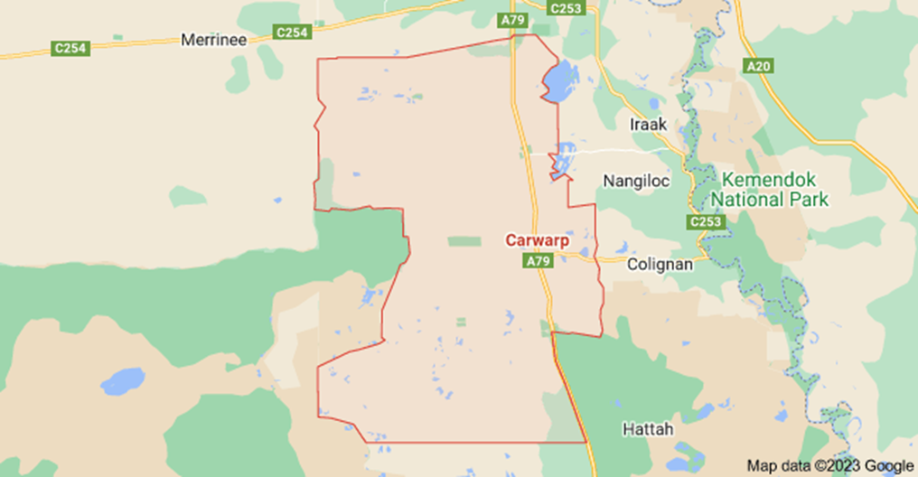

Carwarp is recorded in 1847 as a 64,000 acre pastoral lease. It fronted the river and operated as a sheep station employing the First Nations custodians of this Country, named as Cowarp. By 1853 it ran 10,000 sheep. In 1903 the railway was completed from Ouyen to Mildura and in 1905 an Act passed to supply water extending 30 miles from the Murray River. The area was surveyed for settlement from 1912 under the Closer Settlement Act. The Carwarp district still encompassed an area from the river in the east, to Carwarp West. But the settlement established at the railway siding took the name Carwarp and the eastern district became Iraak and Karadoc. Sidings were also built at Nowingi, Boonoonar and Yatpool to service the neighbouring farming settlements. By 1913 Carwarp had a passenger platform. The train was the reliable method of travel with roads especially from Ouyen difficult by horse and impossible by early vehicles. A reliable road from Hattah through Carwarp and Yatpool to Red Cliffs was not completed until 1930.

Many of the early settlers were from United Kingdom and found the conditions very challenging. Land allocations were announced in 1912. Water was carted by rail. The first years were desperate and the promise of a water supply by channel from the Murray, plus wood cutting and rabbit trapping kept the settlers going. The harsh life cultivated a supportive community. Progress Associations were formed at each siding. Yatpool and Carwarp actively advocated for water, a rail crossing and a school. 1914 was a drought year with poor crops. School at Yatpool commenced in 1915 in a private home. In 1915 a pump was built at the cliffs (near the current boardwalk), to provide water to Yatpool and Carwarp. It was in operation by 1916 but proved to be unreliable and water supply was a continuing issue. Earthen channels were built, dams and bores sunk. A. S. Kenyon’s successful design of an iron clad, ground ‘tank’ was tried and one is preserved at Nowingi. At Carwarp a level crossing, two railway residences and sheep and cattle yards were provided by 1917. School began in a private home, then in the Carwarp Hall. In 1924 they gained a Station Master and the school began on its own site. Many rural schools were dotted around. The last school, Carwarp, closed its doors in 1991.

The settlers were interested in exploring better farming methods. Percy Stewart trialled wheat varieties to improve crop yields and ran field days on his Carwarp farm which brought farmers from all over the Mallee. Carwarp Progress Association supported these endeavours and at a meeting in 1916 Percy Stewart inspired action. The creation of the Victorian Farmer’s Union followed. Albert Allnutt was also a founding member. In 1919 a Carwarp Women’s VFU branch was formed with 13 members. The VFU with other states farmers’ groups became the Country Party and later the Nationals. Stewart entered State, then Federal politics. As minister of Works and Railways he ‘turned the first sod’ for the first Parliament House in Canberra. Carwarp farmer, Albert Allnutt entered Victorian politics as Member for Mildura in 1927. He advocated for his community during the difficult 1930s and showed fairness in issues during the 1939 Red Cliffs Picker’s Riot.
Sport was part of community life. Football, cricket, tennis and horse racing events feature in the press reports as do the social events around them. The Carwarp and Yatpool football teams played each other and in 1920 Red Cliffs’ first team, ‘Diggers’ joined. The teams and supporters came by train, some came from Mildura for the social community event. The rail also supported stump picking excursions raising money for the Mildura Hospital.
The vision of the pioneers was met and Carwarp district grew as a successful farming area. As cultivation became more mechanized, and farming practices improved, the size of the farms increased. Better roads and transport helped to change the community. The range of shopping, facilities and services available within a short drive, now offer greater options for those living on the farms.

Carwarp remains a depot for grain receiving and storage but it has also developed into areas the pioneers would never imagined. Crops have diversified, with some under irrigation. The Carwarp Olam almond processing plant is one of the world’s largest. In the 1960s Yatpool tower offered Sunraysia homes, television. Today Carwarp is the centre for generation of energy through solar power farms. Workers commute daily from elsewhere. These new industries have changed the wider Sunraysia community and bring different challenges for Carwarp with increasing industry and tourist traffic using the highway. But the historic bond remains and Carwarp’s 2023-2028 plan encourages developing a community place with facilities and environment for locals and visitors to appreciate and enjoy.
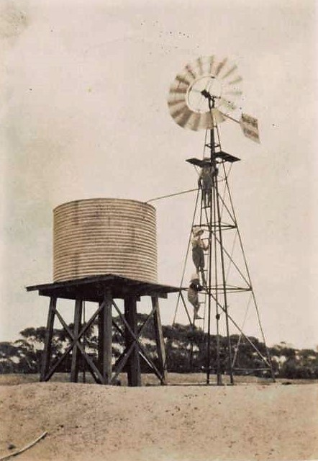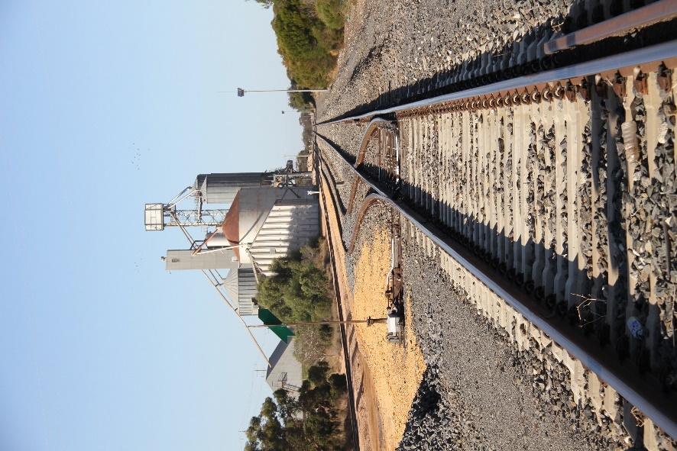

Carwarp Cross family

Township Improvements
Objective: Encourage the community and tourists to utilise public areas
Actions | Next steps | Partners | Links
- Support the development of a playground at Carwarp Hall  - Inspire an act of civic pride working together as a community to clean up, fix up and conserve the environment. | Seek Council support for creating new family playground for young people in Red Cliffs.  Establish partnerships with appropriate services to investigate public community risk and grants.  Identify areas and groups to create a program for regular clean up days.  Investigate programs for roadside and public space clean ups.  Support MRCC to implement ongoing green waste collection.  Provide community education on how to use Snap, Send and Solve regarding illegal dumping of rubbish, overgrown trees, etc. | MRCC Recreation Staff, Community Development staff, Community groups, residents, internal and external stakeholders, MRCC Parks and Garden, Millewa-Carwarp Landcare Group  Community, MRCC Environmental Sustainability Unit, Millewa-Carwarp Landcare Group | - MRCC Recreation Strategy 2021-31  - MRCC Youth Engagement Strategy 2020-23  - MRCC Community Vision 2021-40  - MRCC Environmental Education Plan 2020-24  - MRCC Environmental Sustainability Report 2020-21  - MRCC Litter and Illegal Dumping Strategy 2020-25  - MRCC Waste and Resource Recovery Strategy 2022-26  - MRCC Invasive Plants and Animals Plan 2020-24  - MRCC Vegetation Management Plan 2020-24  - MRCC Parks and Waste Services Environmental Education Plan 2020-2024

Thank You

The Red Cliffs Community Plan working group would like to extend our heartfelt thanks to everyone who took the time to participate in the Red Cliffs Community Plan consultations. Your valuable feedback and insights are greatly appreciated and will help us to better understand the needs and concerns of our community.

Thank you for your continued support and for being an active member of our community. We look forward to working together to make Red Cliffs an even better place to live, work, and play.

