JULY 2020
Quandong Park Master Plan
Table of Contents

1. Introduction 3

2. Quandong Park 5

2.1 Location 5

2.2 The Site 5

2.3 Site User Groups and Key Stakeholders 7

3. Master Plan 8

3.1 Previous Master Plan Objectives and Directions 8

3.2 2009 Master Plan Progress Report 11

4. Future Directions 12

4.1 Development Opportunities 12

5. Master Plan Implementation 13

5.1 Action and Implementation 13

5.2 Priority Actions List 14

6. Appendices 18

Appendix 1 - Consultation and Literature Review 18

Appendix 2 – High Priority Actions 19

Introduction
In 2009 Mildura Rural City Council (MRCC) developed master plans for each of its 12 township recreation reserves. The master plans were developed to provide a framework to guide the planning and development of the reserves for 10 years. As the timeframe for each master plan was nearing its end, MRCC commenced a process to systematically review these master plans.

In 2019, MRCC commenced a review of the Quandong Park Master Plan.

The review has given consideration to the existing Master Plan (2009) as well as site conditions and future anticipated needs of the Reserve’s user groups.

The revised five year Master Plan will provide guidance for MRCC, in their aim to enhance the Reserve and ensure its facilities continue to benefit key user groups as well as the broader local community.

The following process was completed to ensure the revised Master Plan aligned with MRCC’s relevant strategies and policies, and was locally focused.

All uncompleted actions from the 2009 Master Plan that still remain relevant have been incorporated into the 2020 revision and a range of plans, strategies and policies which reference or impact on the future direction of recreation provision in Red Cliffs have also been considered as part of the process.

Numerous MRCC officers were engaged throughout the review process. A key role of these officers was to assess the technical feasibility of proposed user group actions and also identify any infrastructure upgrades deemed necessary for the future operation of the Reserve.

Development of the revised Master Plan has been largely driven by a Reference Group consisting of representatives from the Reserve’s regular user groups. Consideration has been given to the changing needs of these user groups as well as the capacity of all stakeholders to deliver the recommended actions.

A strong focus of the Master Plan review was to ensure that the future direction of the Reserve was based on key elements of sustainable decision making. That is, proposed actions need to be economically viable, technically feasible, environmentally compatible and publicly acceptable.

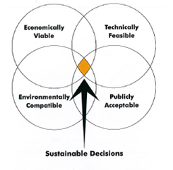

The development of a clear future direction for Quandong Park along with a program of prioritised works, indicative associated costs and potential contributors is provided in section 5.2.

2. Quandong Park

2.1 Location
Located off the Calder Highway and Erskine Avenue, Quandong Park is located in Red Cliffs 16 kilometres south of Mildura.

2.2 The Site
Quandong Park is approximately 26 hectares in size owned by Council freehold.

Figure 1 – Aerial image of Quandong Park

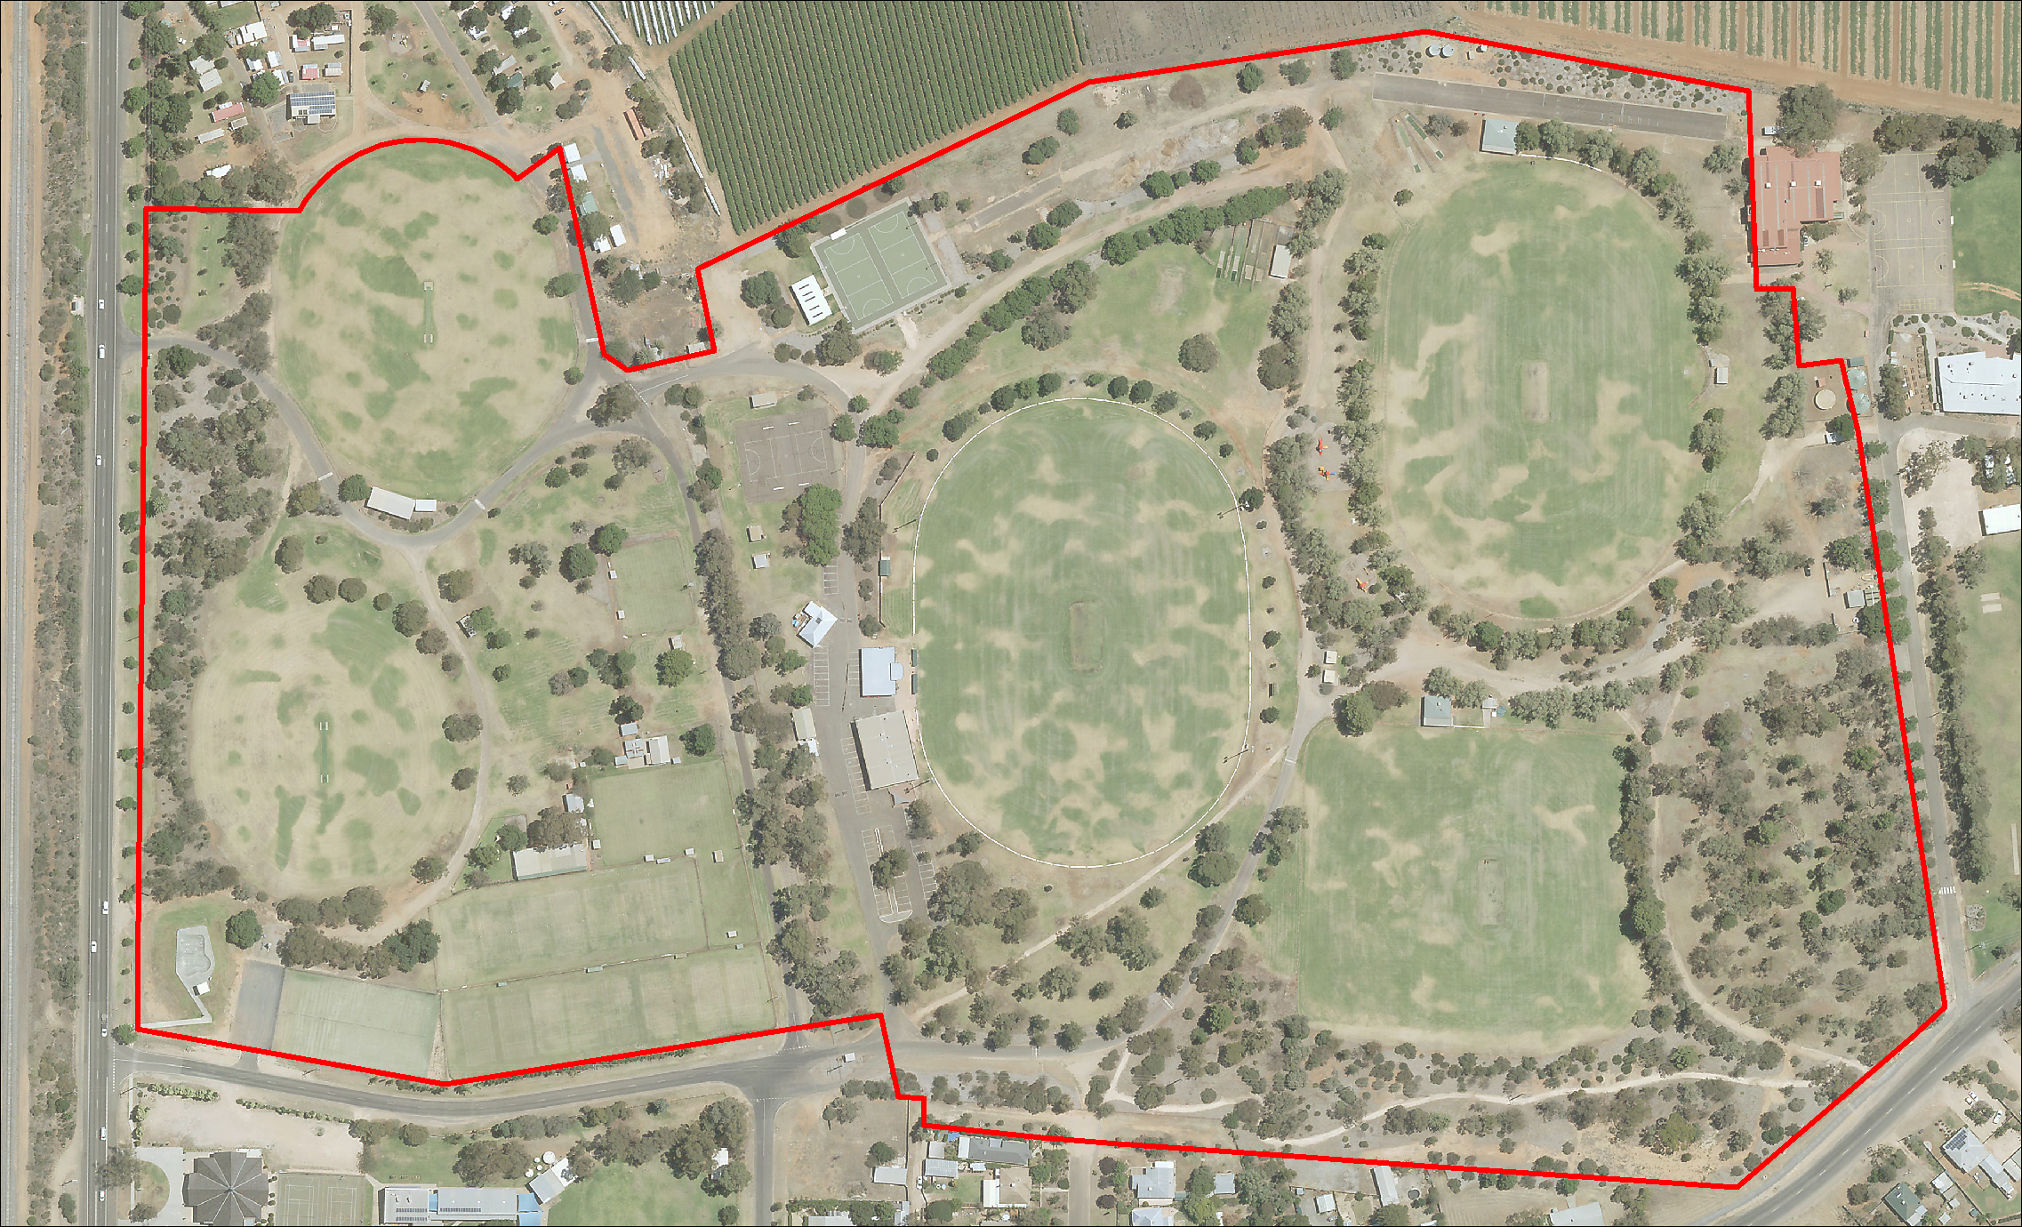

Facilities and Structures

Facilities and Structures on the site include:

- Five sports fields that cater for football and cricket

- Nineteen tennis courts (Fifteen grass, four synthetic grass)

- Two croquet greens

- Two plexi-pave concrete netball courts

- One asphalt netball court

- Two cricket training net facilities

- Eight club room facilities

- Three change room facilities

- Eight storage shed/buildings/kiosk

- CFA training track

- Public toilets

- A skate park

- Two playgrounds

2.3 Site User Groups and Key Stakeholders
There are currently 15 regular user groups based at Quandong Park.

These include:

- Fire Brigade Cricket Club

- Millewa Cricket Club

- Nangiloc and District Football Netball Club (training)

- Nursery Ridge Cricket Club

- Red Cliffs Cricket Association

- Red Cliffs Cricket Club

- Red Cliffs Croquet Club

- Red Cliffs District Kennel Club

- Red Cliffs Football Netball Club

- Red Cliffs Lawn Tennis Club

- Red Cliffs Secondary College

- Red Cliffs Urban Fire Brigade

- South West Cricket Club

- Sunraysia Cricket Association

- Sunraysia Football Netball League

The number of user groups has remained relatively stable since the 2009 Master Plan was developed. Each were given an opportunity to nominate a representative for the ref group, 11 user groups provided representation (refer to Appendix 1 for a list of representatives).

MRCC is responsible for the majority of maintenance tasks at the Reserve with Facility Services and Parks & Gardens both playing significant roles in ensuring the Reserve’s ongoing operation. Minor maintenance such as cricket wicket preparation is carried out by the cricket clubs.

3. Master Plan

3.1 Previous Master Plan Objectives and Directions
In 2009, MRCC commissioned the development of a Master Plan for Quandong Park. The following section provides a summary of the key issues and needs identified in the 2009 Quandong Park Master Plan.

Erskine Avenue and Park Entry Precinct

- Park signage on highway
- Widen transition into / out of Erskine Avenue at junction with Calder Highway
- Tree / vegetation treatment along Erskine Avenue
- Removal of old tennis courts (crusher dust / hard surface) at corner of Erskine Avenue and Calder Highway
- Entry enhancement works.

Ovals 1 & 2 (including new recreation and skate park precinct)

- Development of multi-purpose open space and family recreation area to the south of oval 1 including the installation of a skate park, playground, picnic area and shade structure
- Sealing of the car park between the skate park and the tennis facilities
- Strengthen tree and vegetation plantings.

Tennis & Croquet Precinct

- Construction of four new synthetic grass courts to the west of the existing courts
- Upgrading of watering system on grass courts
- Construct a centrally located / updated toilet facility to service activities in the west precinct of the reserve – skate and dog club facilities
- Addition of four toilets at croquet club rooms
- Formalising and sealing of car park between croquet greens.
New Netball Precinct

- Re-routing and sealing primary road to the south
- Construct eight plexi-pave netball courts with lighting
- Install protective netting / fencing around new courts
- Demolish existing netball change room and temporary amenities facility
- Construction of new netball amenities block and shelter
- Remove existing netball / basketball court and revegetate
- Tree / vegetation plantings in new vegetation zone.
Oval 3 Precinct

- Demolish existing home and away change rooms and gym
- Replace with one building to accommodate home and away teams and gym
- Upgrade / renovate oval surface
- Seal road to the west of the club rooms and around north perimeter of oval
- Upgrade cricket nets to the north of oval 3
- Demolish old red brick building
- Upgrade scoreboard
- Demolish old toilet blocks on the east side of oval (near scoreboard)
- Bollards and landscaping at the bottom of the spectator mound to prevent vehicle access to the mound, other than for special event days
- Strengthen tree / vegetation plantings at base of spectator mound.

New Pedestrian Only Precinct

- Construct new toilet block
- Bollards and landscape treatment to create a pedestrian only zone between ovals 3 & 4
- Strengthen tree / vegetation planting
- Upgrading of playground
- Installation of tables, seating and shelter.

Oval 4 Precinct

- Replace perimeter fencing with bollards and perimeter seating
- Remove baseball infrastructure
- Upgrade / renovate oval surface
- Permanently close all vehicle access gates along the east boundary with the school. Provision for pedestrian gate
- Install training lights at north end of the oval
- Remove Athol Pines from along north boundary of reserve and replace with more appropriate species
- Creation of loop trail around oval 4 and pedestrian precinct to link with trail in south-west corner.

Oval 5 Precinct

- Pavilion redevelopment including construction of change rooms, toilets / showers, kitchen / kitchenette, multi-purpose room, administration room and store room
- Extension of pedestrian / recreation zone to area between ovals 4 & 5 – bollard and landscape treatment
- Vegetation / tree planting in pedestrian / recreation zone
- Installation of seating and tables
- Realignment / extension of oval to north and south
- Extension of irrigation system
- Oval boundary fencing and seating
- Provision for informal car parking around west and south boundaries of oval.

South-East Corner & South Boundary Precinct

- Remove vehicle access gate in south-east corner of boundary fence and install pedestrian access only
- Strengthen vegetation plantings in south-east corner
- Construct access road for council / service vehicles along east and south boundaries of oval 5
- Construct loop pathways through south-east corner to link with existing trail along south boundary fence
- Strengthen tree / vegetation planting between boundary and oval 5.

Other Items

- Seal apron entrance on the north Calder Highway entrance
- Signage – along highway
- Signage – internal signage
- Progressive removal of Athol Pines.

3.2 2009 Master Plan Progress Report
The following list provides a summary of key developments that have been completed at Quandong Park since the development of the 2009 Master Plan:

- Construction of skate park

- Construction of four synthetic grass tennis courts

- Car parking between skate park and tennis courts

- Construction of two plexi-pave netball courts including lighting

- Construction of netball change room facility

- Installation of electronic scoreboard

- Vegetation plantings.
A review of the status of actions from the 2009 Quandong Park Master Plan highlighted that a large number of actions remain incomplete. However, it should be noted that recent changes in user group development priorities has meant that these may no longer be applicable.

4. Future Directions

4.1 Development Opportunities
A number of site development opportunities were identified throughout the consultation process with user groups and Council officers. The following opportunities received strong support and therefore have been identified as high priority.

- Red Cliffs District Kennel Club and Millewa Cricket Club Facility Upgrade

- Cricket Net Upgrade

- Extension to the facility leased by the Red Cliffs Football Netball Club

- Upgrade the turf wicket irrigation systems at ovals 3, 4 and 5

- Construction of shared facility between ovals 3, 4 and 5.

5. Master Plan Implementation

5.1 Action and Implementation
The revised Master Plan for Quandong Park has been developed to provide actions that are practical and realistic. Many actions will require further stakeholder consultation through their detailed design and implementation phases.

The priority actions of the Master Plan have been established based on the following criteria:

Priority 1 - High level demand by clubs, safety and regulatory compliance.
Priority 2 - Medium level demand by clubs, necessary repairs to maintain operations.
Priority 3 - Upgrades / refurbishments / exclusive requests.

The implementation of the Master plan is reliant upon the capacity of a range of stakeholders to actively attract and negotiate funding. To this end, it is important to appreciate that implementation of the Master Plan is not the sole responsibility of one stakeholder. Rather, its success is dependent upon a range of partners to come together and work towards mutual goals.

The action list in Section 5.2 identifies the range of partners that are involved throughout the implementation of the works program. Funding contribution recommendations have been made on the basis of:

- Which partner/s will receive direct benefit from the works
- The assumed capacity of partners to contribute to works
- The understanding that Council, together with the user groups, has a responsibility to preserve asset integrity, and respond to works that would otherwise contribute to asset deterioration and compromise the functionality of the asset.

Finally, recommended contributions have not taken into account the expected in kind contributions. It is anticipated that in kind contribution which directly reduces the capital cost of work is a fair and legitimate avenue for all clubs to contribute to works. However, it should be noted that Council discretion will be used in assessing and/or approving any proposed in kind.

In some cases, identified projects may also be eligible for funding from Council’s grants or State and Commonwealth Government funding programs. In the Priority Action List below, potential funding partners are identified. For a number of these projects, there will a requirement for user groups to contribute financially. The values of contribution will be confirmed through the development process of each project and will be subject to external funding streams available at the time.

5.2 Priority Actions List
Ref | Task | Priority | Indicative Cost | Potential Funding Partners | Comments
Oval 1
1 | Upgrade the width of the center wicket to Cricket Victoria standards | Priority 2 | $7,500 | Clubs, Council
Oval 2
2 | Facility Upgrade - Stage 1: Investigate the feasibility of extending the existing facility to service the needs of the Red Cliffs & District Kennel Club, and the Millewa Cricket Club | Priority 1 | $5,000 | Clubs, RCCA, Council
3 | Facility Upgrade - Stage 2: Develop Design Plans for the upgrade of the existing facility to service the needs of the Red Cliffs & District Kennel Club, and the Millewa Cricket Club | Priority 1 | $10,000 | Clubs, RCAA, Council
4 | Facility Upgrade - Stage 3: Construction of facility upgrade as per design plans | Priority 1 | TBC | Clubs, RCCA, Council, State Gov’t
5 | Install picket fence around boundary of oval | Priority 2 | $195/m | Club, Council | Indicative cost is a per meter rate for the supply and installation of 900mm high powder coated steel picket fencing
Oval 3
6 | Construction of proposed cricket training nets for joint use of 5 clubs - include provision of storage sheds behind the nets to enable the clubs to store training equipment. | Priority 1 | $250,000 | Clubs, RCCA, Council, SSA, State Gov’t
7 | Construction of additional three pitch cricket training nets when existing nets located at Oval 4 have reached end of life | Priority 2 | $75,000 | Clubs, RCCA, Council, SSA, State Gov’t
8 | Install provision (power and water) for food vendor caravans in every pocket of Oval 3 | Priority 3 | TBC | SFNL, Council
9 | Facility Development - Stage 1: Prepare construction plans for the extension of the Red Cliffs Football Netball Club clubrooms. Extension to incorporate change rooms for football and cricket, umpire change rooms, storage for football and cricket, public toilets and other required facilities as directed by the relevant state sporting bodies facility guidelines | Priority 1 | $10,000 | Clubs, SFNL, RCCA, Council | Multi-use facility – football in winter, cricket in summer
10 | Facility Development - Stage 2: Construction of the extension to the RCFNC club rooms - includes the demolition of the existing public toilets in this area | Priority 1 | TBC | Clubs, SFNL, RCCA, Council, SSA, State Gov’t | Multi-use facility – football in winter, cricket in summer
11 | Lighting upgrade - Stage 1: Prepare lighting specification to provide AFL match standard lighting, and Cricket Victoria match standard lighting to the oval | Priority 2 | $5,000 | Clubs, Council | Incorporate LED lighting
12 | Lighting upgrade - Stage 2: Installation of lighting upgrade as specified | Priority 2 | $350,000 | Clubs, SFNL, RCCA, Council, SSA, State Gov’t
13 | Enhance spectator viewing on “the hill” with installation of a roof and weather proof section at the very top hill against the exiting fence | Priority 2 | TBC | Club, Council | Verandah and concrete terracing to be constructed north of the can shed approx. 3m out from the fence
14 | Relocate the coaches boxes and provide an interchange box | Priority 2 | $12,000 | Club, Council
Oval 4
15 | Installation of a watering system around the net area west of the FBCC clubrooms | Priority 1 | $5,000 | Club
16 | Extension of outdoor seating area to the south and west of the FBCC clubrooms including BBQ, outdoor shelter and seating | Priority 2 | TBC | Club, Council
17 | Inclusion of more aluminum seating to be placed along the eastern and western sides of the oval | Priority 2 | $650/seat | Club, SFNL, Council | Indicative cost is for the supply and installation of one 6m long seat
18 | Provision of coaches boxes | Priority 2 | $15,000 | Club, Council
19 | Investigate the demolition and removal of existing baseball shed | Priority 2 | TBC | Council | Dependent upon condition assessment and alternate use
Oval 5
20 | Upgrade to porch/decking at front of current onion patch facilities, with a disabled ramp on western side of the building & shade coverings on eastern side for spectators | Priority 1 | TBC | Club, RCCA, Council
21 | Upgrade the NRCC rooms to include kitchen with bar, function areas showers, toilets, verandah at front and side | Priority 2 | TBC | Club, RCCA, Council | Dependent upon final outcome of proposed football/cricket change room facility (refer Items 22, 23 & 24) and whether that facility includes a social space with kitchen and bar facilities. Also subject to a condition assessment of the existing club rooms.
Ovals 3, 4 & 5
22 | Upgrade the irrigation systems on Ovals 3, 4 & 5 to enable independent watering of turf wickets | Priority 1 | $20,000 | RCCA, Council
23 | Facility Development - Stage 1: Investigate opportunities to provide a shared social space in the proposed sports facility | Priority 1 | $0 | Clubs, RCCA, Council
24 | Facility Development - Stage 2: Prepare construction plans and specifications for the construction of a sports facility. Facility to incorporate change rooms for football and cricket, umpire change rooms, storage for football and cricket, an office for the RCCA, public toilets and other required facilities as directed by the relevant state sporting bodies facility guidelines. The provision of a shared social space with kitchen, kiosk and bar facilities will be determined prior to the preparation of construction plans. | Priority 1 | $10,000 | Clubs, RCCA, SFNL, Council | Multi-use facility – football in winter, cricket in summer
25 | Facility Development - Stage 3: Construction of the sports facility - includes the demolition of existing public toilets in this location | Priority 1 | TBC | Clubs, SFNL, RCCA, Council, SSA, State Gov’t | Multi-use facility – football in winter, cricket in summer
Croquet Precinct
26 | Flood Lighting – Stage 1: Prepare lighting specifications to conform to the lighting requirements as specified in Croquet Victoria’s Croquet Facility Guide | Priority 1 | $5,000 | Club, Council
27 | Flood Lighting – Stage 2: Installation of lighting as specified | Priority 1 | $80,000 | Club, Council, State Gov’t
28 | Retractable shade cloth over two courts | Priority 1 | TBC | Club, Council, State Gov’t
Netball Precinct
29 | Investigate the feasibility and demand for the provision of additional netball courts | Priority 2 | $0 | Club, SFNL, Council
30 | Install netball benches, scorer and time keeper covered seating | Priority 1 | $25,000 | Club, Council
31 | Netball Facilities Development - Stage 1: Prepare construction plans for the extension of the existing change room facility to incorporate umpire change, storage and shelter for viewing | Priority 2 | $10,000 | Club, SFNL, Council
32 | Netball Facilities Development - Stage 2: Construct the extension of the existing change room facility to incorporate umpire change, storage and shelter for viewing | Priority 2 | TBC | Club, SFNL, Council, State Gov’t
33 | Playground near Netball Precinct | Priority 3 | $75,000 | Club, Council | To be included in the development of the traffic management plan and development of a pedestrian precinct
34 | Installation of seating around netball courts | Priority 3 | $10,000 | Club, Council
Other Items
35 | Develop a traffic management plan for the park, including pedestrian precinct, and formal car parking taking into account the proposed development priorities | Priority 1 | $5,000 | Council
36 | Undertake condition inspections of all buildings | Priority 1 | TBC | Council
37 | Review irrigated surfaces with the intention of reducing water use. Investigate converting some currently irrigated areas to native vegetation, mulched gardens, stone surfaces or other. | Priority 2 | $0 | Council
38 | Installation of a basketball ring area | Priority 2 | TBC | Council | At the old netball / basketball court
39 | Emergency services vehicle signage | Priority 1 | $15,000 | Council

Note: Costs for identified works are indicative only and are based on 2019 prices and will likely be subject to change at time of project commencement.
Indicative costs listed as TBC (to be confirmed) are due to the exact scope of those action items being unknown at this stage.

6. Appendices

Appendix 1 - Consultation and Literature Review
A – 1.1 Stakeholder Consultation List

A list of stakeholders consulted in the development of the Quandong Park Master Plan is provided below:

- Jamey Mullen – Manager Leisure & Cultural Services
- Thomas Stevenson – Recreation Development Coordinator
- Dawn Johnston – Recreation Support Officer
- Andrew Lucchesi – Recreation Officer
- Sue O’Brien – Recreation Officer
- Alana Nolen – Environmental Health Coordinator
- Anne Ross – Community Development Coordinator
- Bonnie Pettett – Environmental Sustainability Coordinator
- Charmaine Calis – Governance & Risk Coordinator
- Dean Umback – Parks & Gardens Coordinator
- Grant Follett – Parks Team Leader - Urban
- Greg Sutton – Infrastructure Works Coordinator
- Jason Kane – Facility Services Coordinator
- Kylie Sergi – Strategic Asset Systems Coordinator
- Karen Milner – Acting Strategic Asset Systems Coordinator
- Lindy Pain – Parks & Gardens Team Leader – Rural
- Michael Vaughan – Infrastructure Services Coordinator
- Nardia Baker – Acting Environmental Sustainability Coordinator

- Parthee Gana – Engineering Coordinator
- Sharyn Arnold – Building Projects Team Leader
- Jody Richardson – Service Planning Coordinator
- Kealey Lush – Property Officer
- Nicole Jamieson – Property Management Support Officer
- Shane Fielding – Fire Brigade Cricket Club
- James Walker/Peter Kelly – Millewa Cricket Club
- Nicole Newey – South West Cricket Club
- Geoff Christensen – Red Cliffs Cricket Association
- Phil Hensman – Red Cliffs Croquet Club
- Desley Orr Reid – Red Cliffs District Kennel Club
- Brendan McGillivray/Paul Matheson – Sunraysia Football Netball League
- Dean Connolly/Craig Thornton – Red Cliffs Football Netball Club
- Gavin Lynch – Red Cliffs Lawn Tennis Club
- Nathan Riordan – Red Cliffs Secondary College
- Mathew Maher – Red Cliffs Urban Fire Brigade

A – 1.2 Literature Review

- Quandong Park Master Plan 2009-2019
- Mildura Recreation Assessment 2013
- Recreation Strategy 2008
- Public Open Space Strategy 2004

Appendix 2 – High Priority Actions

Red Cliffs District Kennel Club and Millewa Cricket Club Facility Upgrade | Priority 1
Cricket Net Upgrade | Priority 1
Extension to the facility leased by the Red Cliffs Football Netball Club | Priority 1
Installation of an irrigation system around the cricket nets at oval 4 | Priority 1
Upgrade the facility leased by Nursery Ridge Cricket Club | Priority 1
Upgrade the turf wicket irrigation systems at ovals 3, 4 and 5 | Priority 1
Construction of a shared change facility between ovals 3, 4 and 5 | Priority 1
Installation of flood lighting at the croquet precinct | Priority 1
Installation of a retractable shade shelter at the croquet precinct | Priority 1
Installation of netball benches, scorer and time keeper covered seating at the netball precinct | Priority 1
Develop a traffic management plan for the park | Priority 1
Undertake a condition inspection of all buildings | Priority 1
Installation of emergency vehicle signage | Priority 1

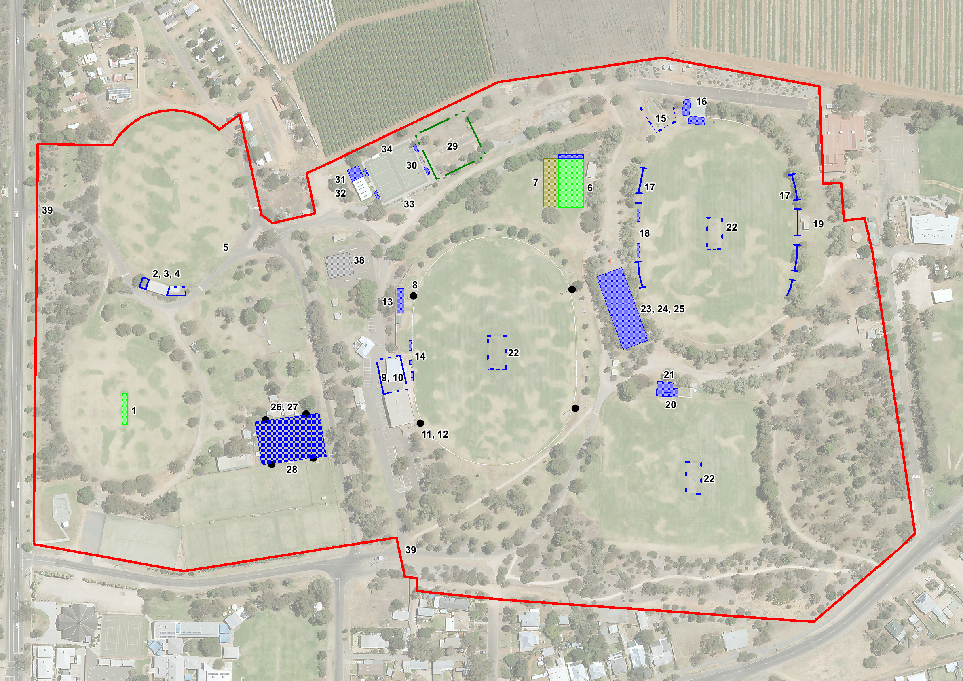
Quandong Park Master Plan July 2020

